`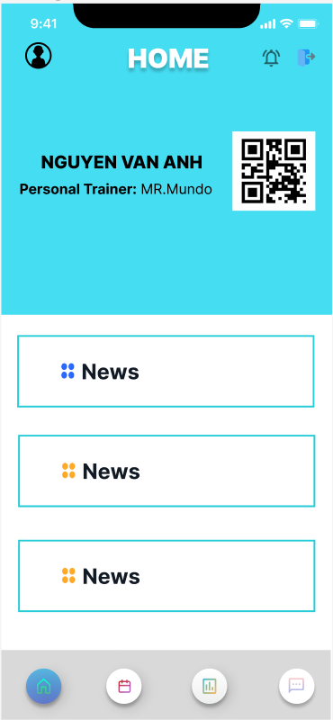

**Data Dictionary for the “Home” screen**

| **#** | **Component** | **Comp.Type** | **Editable** | **Mandatory** | **Default Value** | **Description** |
| --- | --- | --- | --- | --- | --- | --- |
| 1 | Logout | Button | No | No | N/A | Logout account of user out app |
| 2 | QR code | Image | No | No | N/A | Scan to check information of customer |
| 3 | Home button | Button | No | No | N/A | If user click button it will link to home page includes:  - Show other buttons in the app, used to link to the page including: notification, calendar, statistic, message.  - Show the QR code of the user to check-in. |
| 4 | Calendar button | Button | No | No | N/A | If user click button it will link to calendar page includes:  - Page will show the training schedule of the user in a week or month.  - Users can change their training schedules. |
| 5 | Notification button(Bell Icon) | Button | No | No | N/A | If current user click this button it will Link to page includes:  -What the gym have published such as : holiday, discount promotion, new exercises  - Notification adapt every individual users belong to collections of exercises |
| 6 | Statistic Button | Button | No | No | N/A | If current user click this button it will Link to page includes:  -Customer’s body measurements summary like full hip, waist, weight, height, fat rate and so on  -Productivity chart record during workout process |
| 7 | Message button | Button | No | No | N/A | If user click button it will link to box chat page includes:  _ Customer can contact with their PT by direct message  _ Display with message content, texting area with send button and |
| 8 | Avatar Image | Button | No | No | N/A | When the user clicks on the Avatar, it will link to the profile page of the user account.  The user page includes information such as: name, age, date joined,etc. |
| 9 | News | Image/Text | No | No | N/A | Shows news related to the activities of the gym |